How to set your computer for using the CyberStreet Dial up service.

Part 1. Establishing the Dial-Up Networking Connection.

First you will need to double-click on the My Computer icon on your Windows desktop.
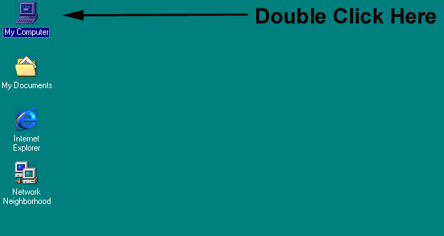

Then double click on the Dial- up networking icon in the window that appears after double clicking on my computer.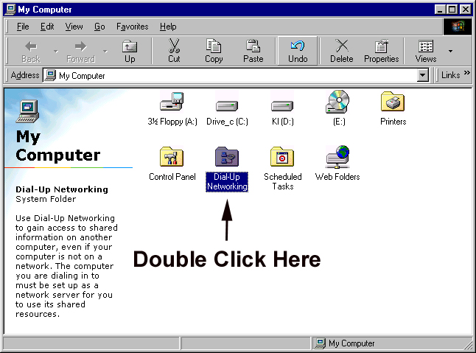
If you have never used dial up networking before, you will be taken automatically to the next step and will not see the screen displayed below.
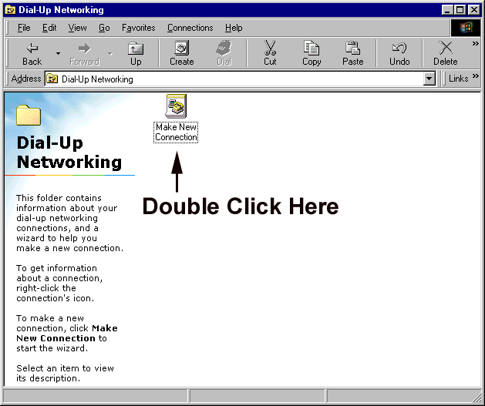

After double clicking the make new connection con the following screen should appear, or will appear automatically if you have never established a dial up service on the computer previously.
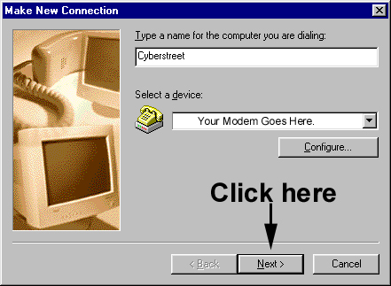

For the name of the computer to be dialed, please enter CyberStreet.
If this screen does not appear, and instead you see a screen describing the functions of Dial up networking, simply click on the next button at the bottom of the window.

After Clicking next on the window displayed above, you will be presented with a screen similar to the one below. In the space provided for Telephone number, please type in the # corresponding to the listed number below for the area you will be accessing from, including the area code.

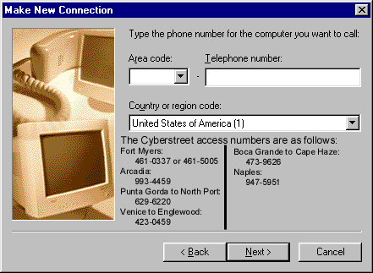

Once this information is entered, please click on the next button.
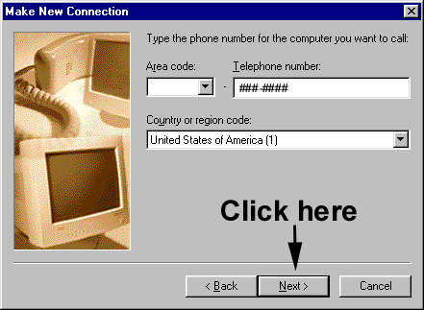

And then Click on the Finish button.
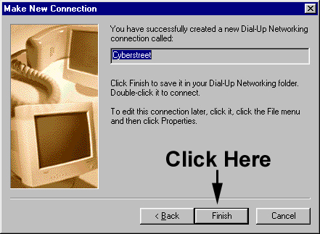
Now we need to provide you with access to the dial up profile you have just created. In order to do this we will be creating a shortcut to the profile on your windows desktop.

To do this, please Right click on the CyberStreet icon you have created.
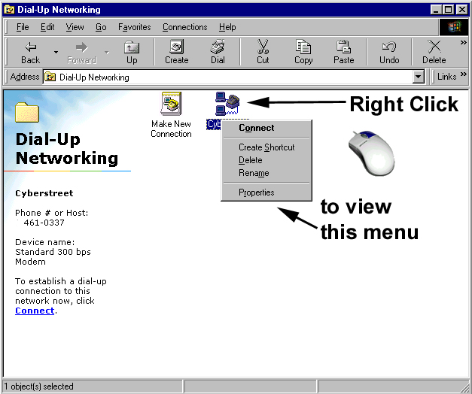

Then click on the Create Shortcut option.
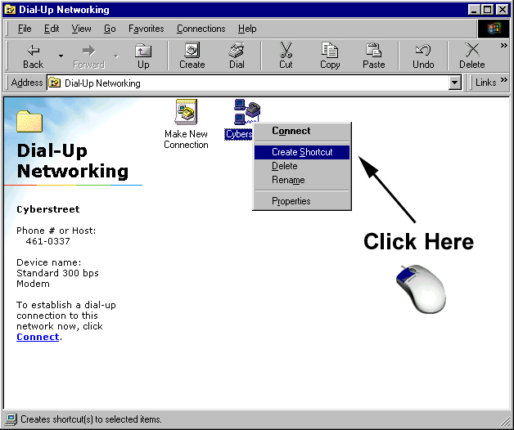
This will force the following dialogue box to appear.
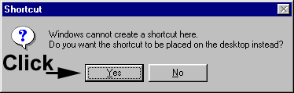

As pictured, you will need to click on the yes button.

This will create an icon on you desktop that you use to connect to the Internet that looks similar to this.
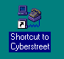

Double clicking on this icon will allow you to connect to the Internet and later view web pages or read e-mail or any other Internet related tasks accessible through a dial up connection to the Internet.

The connection dialogue will appear similar to this.
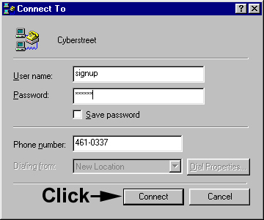

Once your user name and password are entered into the connection dialogue you may opt to save the password to alleviate the need to type your password every time you connect to the Internet. The account listed above has the user name of signup and the password of signup and is valid only for use to use our online signup form on CyberStreet to establish your account for full Internet access. When you have an account at CyberStreeet, simply replace the user name and password for the signup account with your own valid account information and you will be able to access resources beyond CyberStreet’s network.

Before you connect to CyberStreet for the first time, we need to ensure that your computer is not attempting to dial CyberStreet as a long distance number.
In order to do this, please follow the images below.
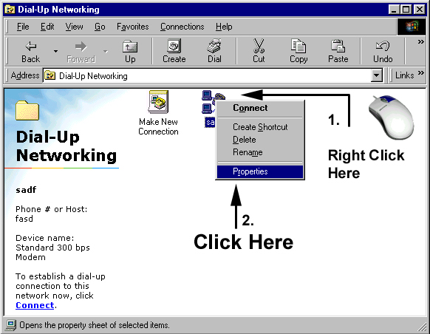
After right clicking on the CyberStreet icon, and clicking on properties, the following window will appear.
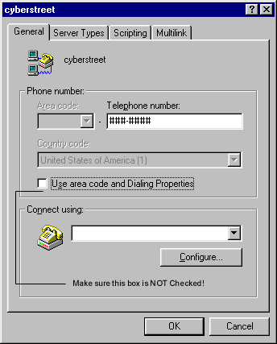

it is very important that the checkbox for using the area code and dialing long distance is not checked, if it is, then it is very likely that you will not be able to connect to CyberStreet.

